**Assignment Day 4**

Q1)find out mail server

Ibm.com

Wipro.com

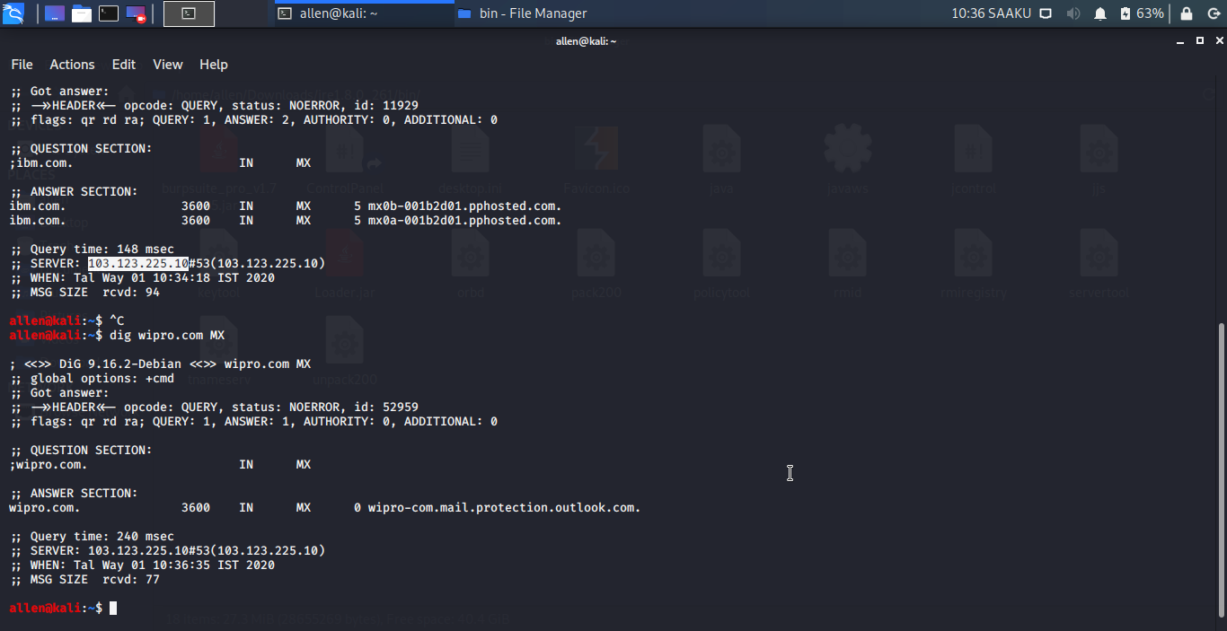

Q2. Find out location where these email server located

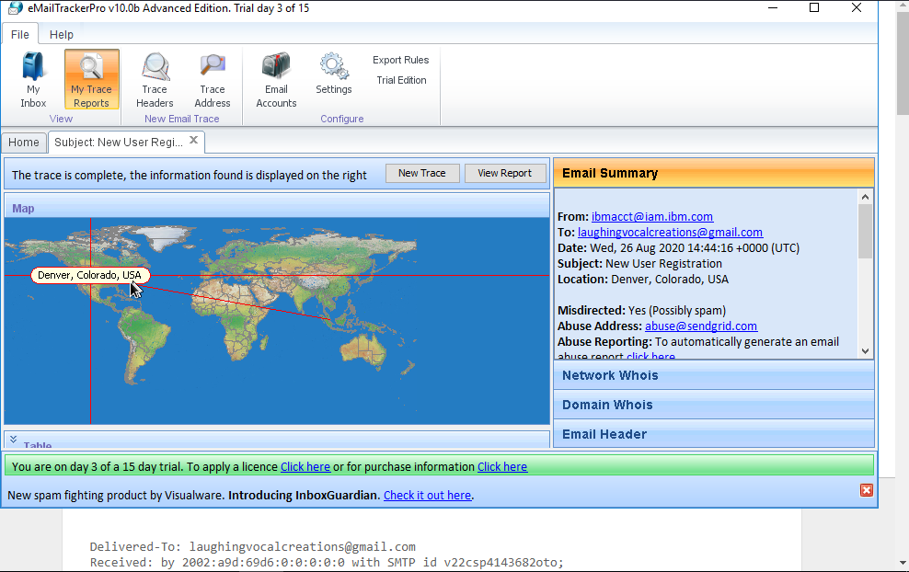

Ibm :- Denver, Colorado, USA

Wipro :- 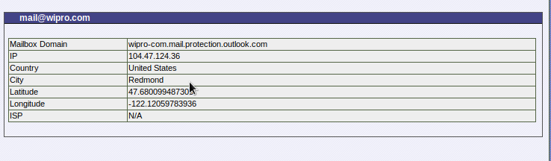

I got :- Redmond

**Q**3. Scan and find out port numbers open 203.163.246.23.

**203.163.246.23**

**Command:- nmap ibm.com -p 203,163,246,23**

**nmap wipro.com -p 203,163,246,23**

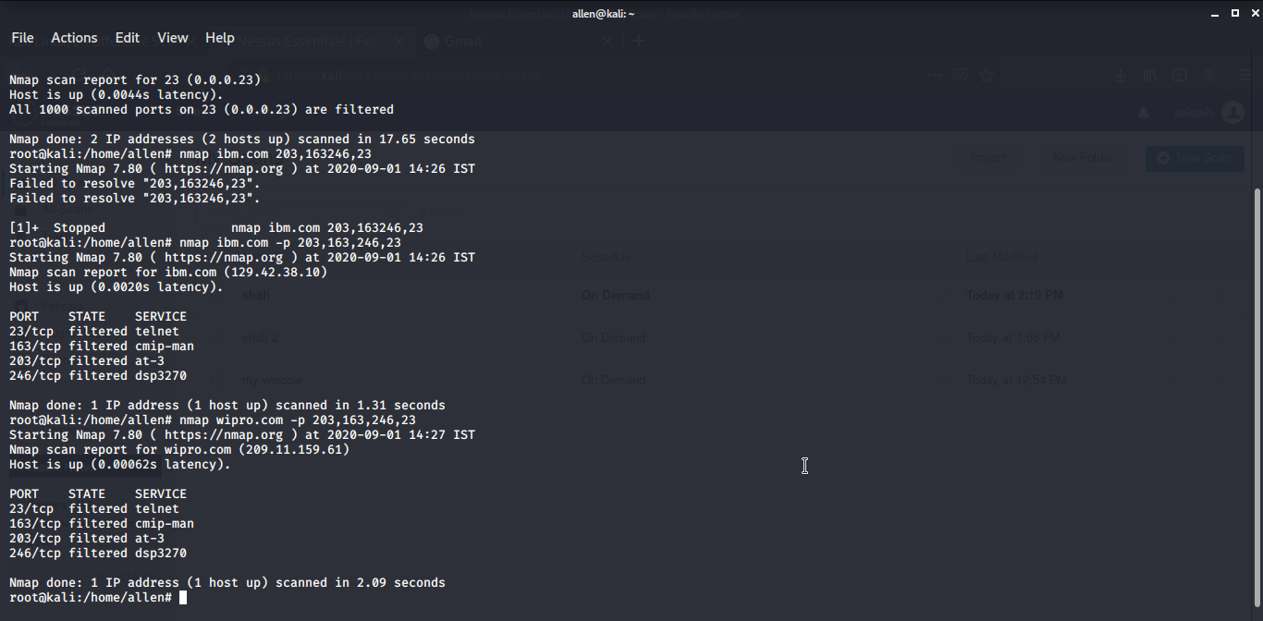

Q4. Install Nessus and scan destop/laptop

